CS 340 README Template

About the Project/Project Title

This project consists of a Python CRUD module used to interact with a MongoDB database containing Austin Animal Center animal records. The module supports Create, Read, Update, and Delete operations. The broader goal of this project is to separate database logic from client-side code so that database access can be handled in a consistent and reusable way. This approach supports a basic client/server design. This includes a web-based dashboard with radio button filters, a data table, Pie chart, and a map.

Motivation

The motivation for this project was to create a reusable and organized way to interact with the MongoDB database without duplicating database code across multiple scripts or notebooks. By separating database access into its own module, the code is easier to maintain and extend over time. This structure also makes it easier to test database functionality independently before integrating it into a larger application. That was especially helpful when validating individual CRUD operations during development.

Getting Started

To run this project, the Austin Animal Center dataset must already be loaded into MongoDB, and a valid database user must be configured. The CRUD module file is placed in the project directory and imported into a Python script or Jupyter Notebook. An instance of the AnimalShelter class is then created, which establishes a connection to the database and allows CRUD operations to be performed using the class methods.

Installation

The following tools are required to use this project:

- MongoDB to store and manage the animal records
- mongosh to inspect the database and verify document structure
- Python 3 to run the CRUD module
- PyMongo to connect Python to MongoDB
- JupyterLab (Codio environment) for development and testing

MongoDB was selected because it supports flexible document-based storage, which works well with the structure of the animal outcome data. PyMongo was chosen because it is the official MongoDB driver for Python and provides direct access to database and collection operations using standard Python data types. For the dashboard, Dash and Plotly Express were used for the visuals, while Dash Leaflet was use for the mapping.

Usage
The CRUD module is used by importing it into a Python script or notebook and instantiating the AnimalShelter class. Once instantiated, the module provides methods for interacting with the database. The create() method inserts a new document into the database, while the read() method retrieves documents that match a provided query. The update() method modifies existing documents that match a query, and the delete() method removes documents from the database. Together, these methods provide full CRUD functionality for managing animal records.
When accessing through the dashboard notebook, selectable filters are above a table, which allow users to select preset filters based on the categories defined by the client. The user needs only to select the filter, and the table, pie chart, and map will update with the relevant data.

Code Example

from CRUD_Python_Module import AnimalShelter

shelter = AnimalShelter("aacuser", "StrongestPasswordEver123")

test_doc = {
"animal_id": "A1994MIL",
"name": "Milo",
"animal_type": "Dog",
"breed": "Jack Russell Terrier Mix",
"color": "White",
"sex_upon_outcome": "Neutered Male",
"age_upon_outcome": "4 years",
"outcome_type": "Adoption"
}

create_result = shelter.create(test_doc)
print("Create result:", create_result)

results = shelter.read({"animal_id": "A1994MIL"})
if results:
print(results[0])

update_result = shelter.update(
{"animal_id": "A1994MIL"},
{"name": "Milo Updated"}
)
print("Update modified count:", update_result)

delete_result = shelter.delete({"animal_id": "A1994MIL"})
print("Delete deleted count:", delete_result)

Tests

Testing was performed using a Jupyter Notebook by executing all CRUD operations and verifying the results. A successful insert confirmed the create() method, while returning matching records confirmed the read() method. Update functionality was verified by modifying an existing record and confirming the changes using a follow-up read. Delete functionality was verified by removing the record and confirming that a subsequent read returned no results.
Testing for the dashboard involved running the web page and verifying that each filter yields only the correct dogs. After that was complete, the pie chart and map were checked the same way.

Reproducing

To reproduce this project, the following steps were performed:
- Import the Austin Animal Center dataset into MongoDB using the mongoimport tool
- Create a MongoDB user account to allow authenticated access to the database
- Place the CRUD Python module in the project directory
- Import and instantiate the module within a Jupyter Notebook
- Execute Create, Read, Update, and Delete operations to verify functionality
- Run the dashboard notebook, and select the desired filters to view the information on the chart and maps below

Process and Challenges
Overall, the process went pretty smoothly, as a good chunk of the final product had been developed in previous assignments, though a few errors were still encountered along the way. As someone who types quickly, I did have more than a few syntax errors, due to typos and improper indentation. Also, though I have played around with html a little bit outside of school, I have no formal experience with it, hence the blandness of the presentation. While working on the filtering callback, runtime errors occurred after selecting the disaster category. This was caused from having an index that was farther along that the entire length of the disaster filter, resulting in an out-of-range indexing during the map update. I added some defense logic to validate the selected row before accessing the filtered dataset: the call back was updated to row 0 when the selected index was none, empty, or greater than the length of the filtered dataframe, so as to ensure the map always references a valid row after dataset resizing. I also included a check to return an empty list when the dataset contained no records. I did include my previous assignment’s style changes as well, and if I had even 1 more day to work on this, I likely would have spent the additional time making the header with the logo, and the filter selection look a little better.

Screenshots

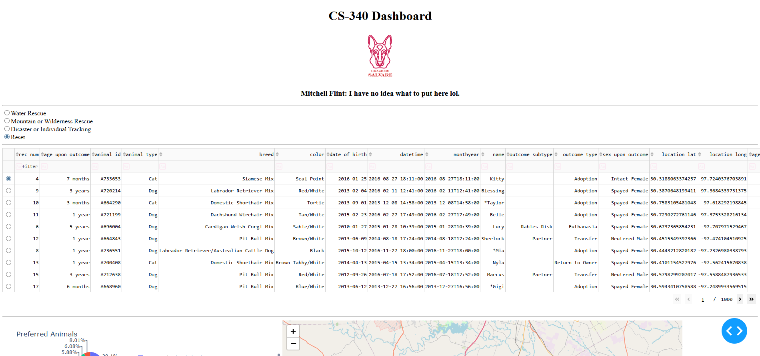
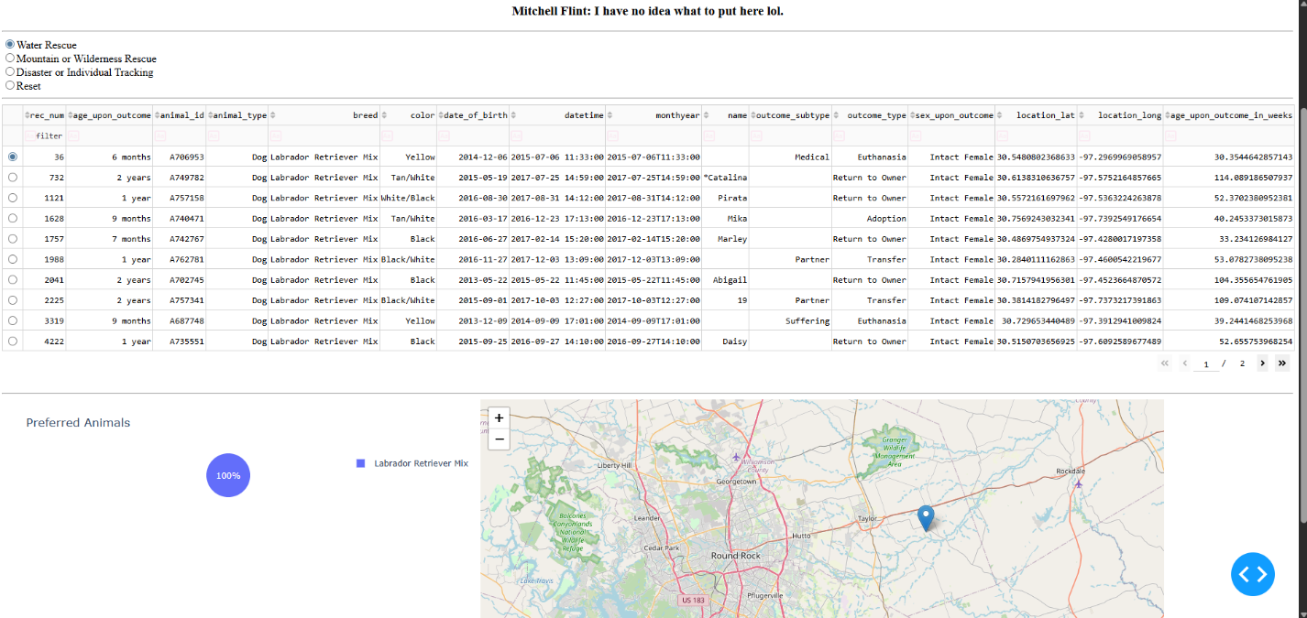
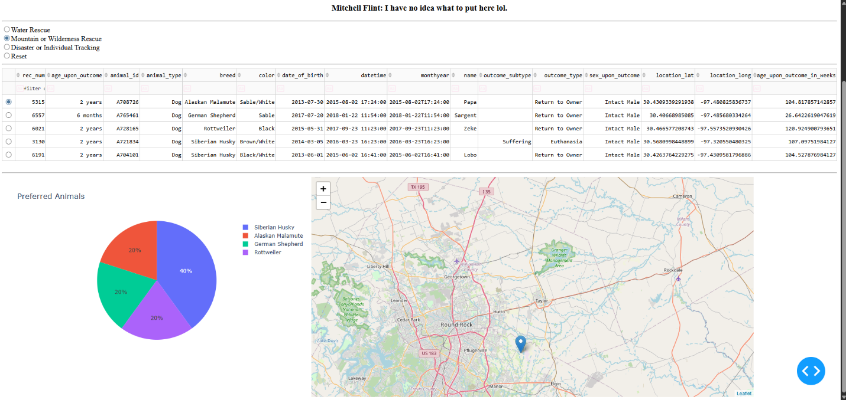
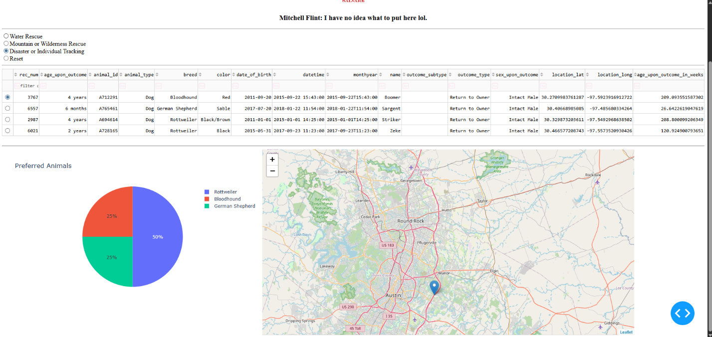
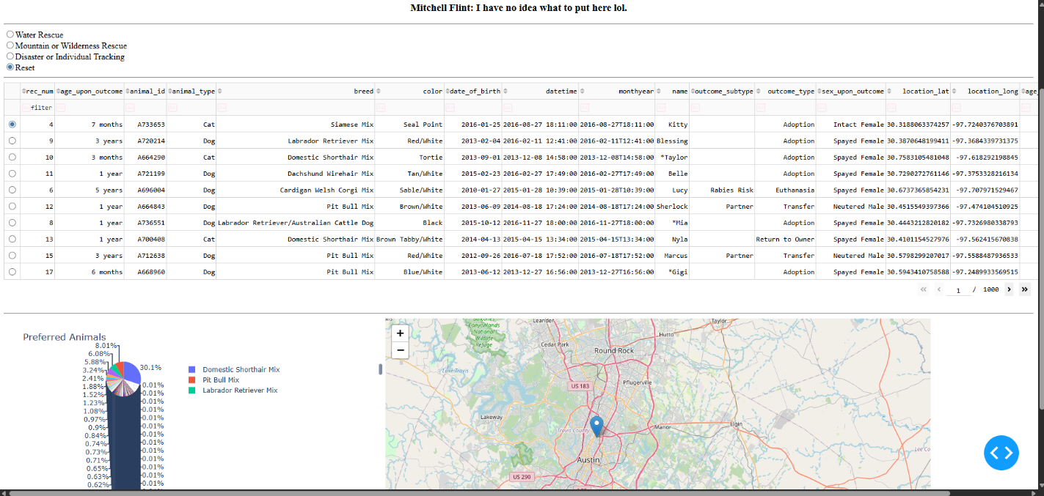

Contact
Your name: Mitchell Flint

